**TASK 4**

Write a program that reads an unspecified number of integers, determines how many positive and negative values have been read, and computes the total and average of the input values (not counting zeros). Your program ends with the input 0.

Flowchart For Task 4 (page 2)

Code For Task 4

**import** java.util.Scanner;

**import** java.text.DecimalFormat;

**import** java.text.NumberFormat;

**public** **class** exe {

**public** **static** **void** main(String[] args) {

**boolean** re, re2, re3, re4;

Scanner keyboard = **new** Scanner(System.***in***);

// 1st do-while start

**do** {

**int** positive = 0, negative = 0, total = 0, number;

String option, option2;

**double** average, count = 0;

System.***out***.println("Input 0 when done, enter the numbers: ");

//2nd do-while start

**do** {

**try** {

**while**((number = Integer.*parseInt*(keyboard.nextLine())) != 0) {

total += number;

count++;

**if**(number > 0){

positive++;

}

**else** **if**(number < 0) {

negative++;

}

}

re2 = **false**;

}**catch**(NumberFormatException e) {

System.***out***.println("Sorry, integers only. Please re-enter number.");

re2 = **true**;

}

}**while**(re2);

//2nd do-while end

//3rd do-while start

**do** {

average = total/count;

System.***out***.println("Which do you prefer? \nEnter A for 2 decimal places, Enter B for 4 decimal places \nEnter C to cancel");

option = keyboard.nextLine();

**if**(option.equals("A")) {

NumberFormat nf = **new** DecimalFormat("#0.00"); //2 decimal

System.***out***.println("\nNumber of positives: " + positive + "\nNumber of negatives: "

+ negative + "\nThe total is " + total + "\nThe average is " + nf.format(average));

re3 = re = **false**;

}

**else** **if**(option.equals("B")) {

NumberFormat nf = **new** DecimalFormat("#0.0000"); //4 decimal

System.***out***.println("\nNumber of positives: " + positive + "\nNumber of negatives: "

+ negative + "\nThe total is " + total + "\nThe average is " + nf.format(average));

re3 = re = **false**;

}

**else** **if**(option.equals("C")){

//4th do-while start

**do** {

System.***out***.println("Do you want to return to the start? \n 1: Yes 2: No");

option2 = keyboard.nextLine();

**if**(option2.equals("1")) {

System.***out***.println("Alright then, all values will be reset.");

re = **true**;

re4 = **false**;

}

**else** **if**(option2.equals("2")){

System.***out***.println("Alright then, bye.");

re = re4 = **false**;

}

**else** {

System.***out***.println("Invalid response. Please try again.");

re = **false**;

re4 = **true**;

}

}**while**(re4);

//4th do-while end

re3 = **false**;

}

**else** {

System.***out***.println("Option does not exist. Please try again. (No spacing and uppercase only)");

re3 = **true**;

re = **false**;

}

}**while**(re3);

//3rd do while end

}**while**(re);

//1st do-while end

keyboard.close();

}

}

**Outputs For Task 4**

1. **Normal:**

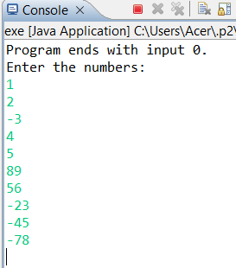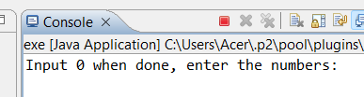

Enter 0

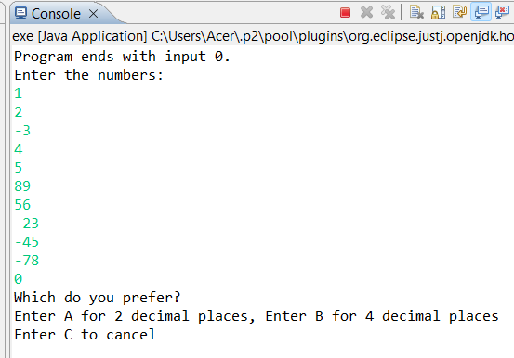

Enter B

Enter A

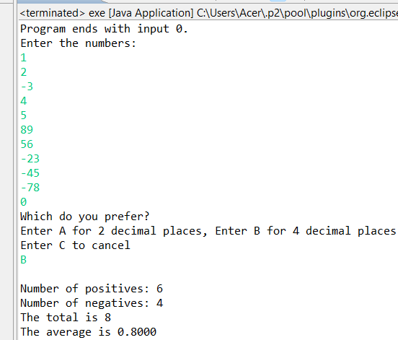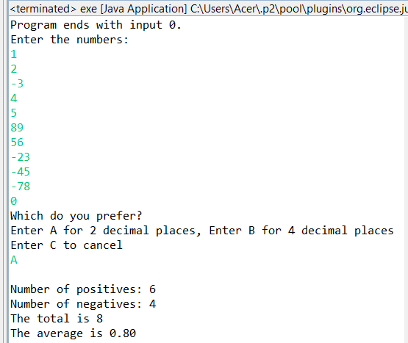

Program ends

Program ends

1. **User Choose Cancel (Enter C)**

**

Program ends

Enter 0

Enter C

Enter 2

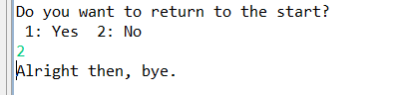

Enter 1

Program does not end

1. **User Did Not Enter Integers**

Decimal

**

Enter alphabets

Left it blank

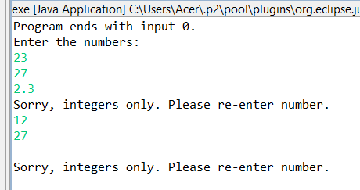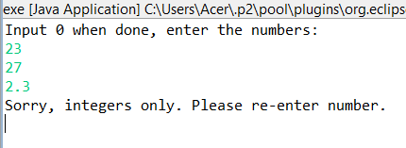

Enter 0

Enter A

Program ends

1. **User Enters Wrong Option 1**

**

Enter D instead of A/B/C

Enter A

Program ends

1. **User Enters Wrong Option 2**

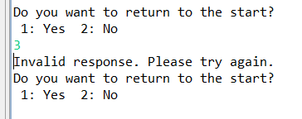**

Program ends

Enter 2

Enter 3 instead of 1 or 2

Enter C